**TECHNICAL -DAY-1**

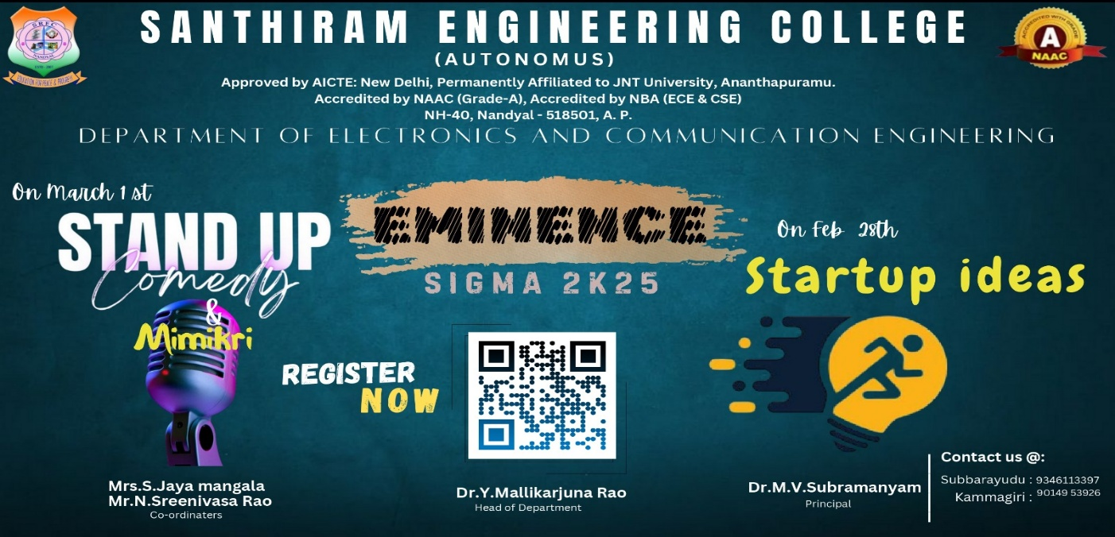

**1.START UP IDEAS-** [**https://shorturl.at/1jvD8**](https://shorturl.at/1jvD8)

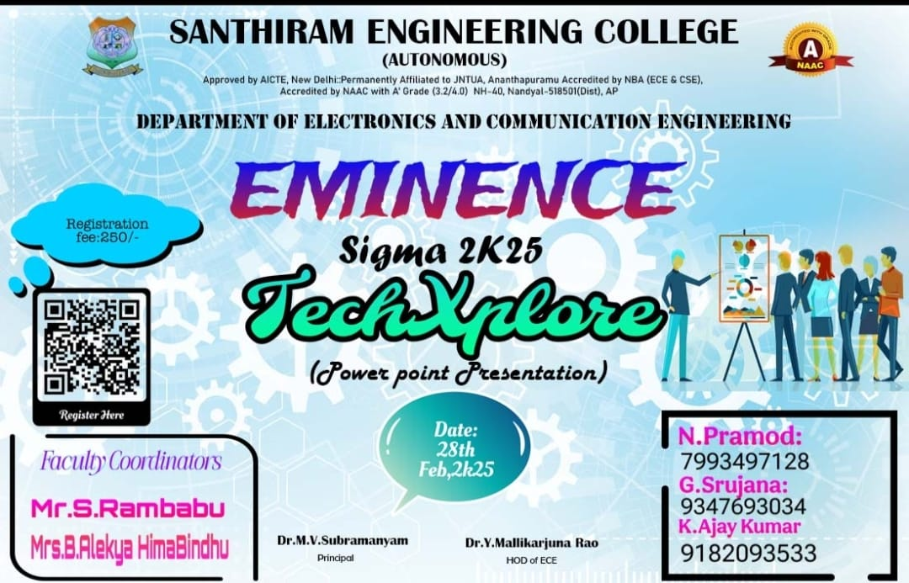

**2. Tech Xplore -**[**bit.ly/4jFzwAX**](http://bit.ly/4jFzwAX)

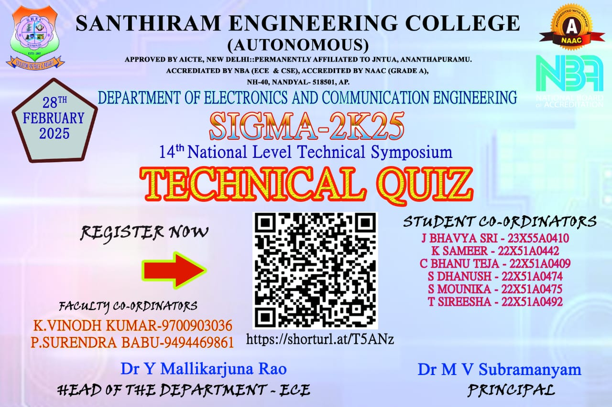

**3. Technical   quiz  -** [**https://shorturl.at/T5ANz**](https://shorturl.at/T5ANz)

**NONTECHNICAL -DAY-2**

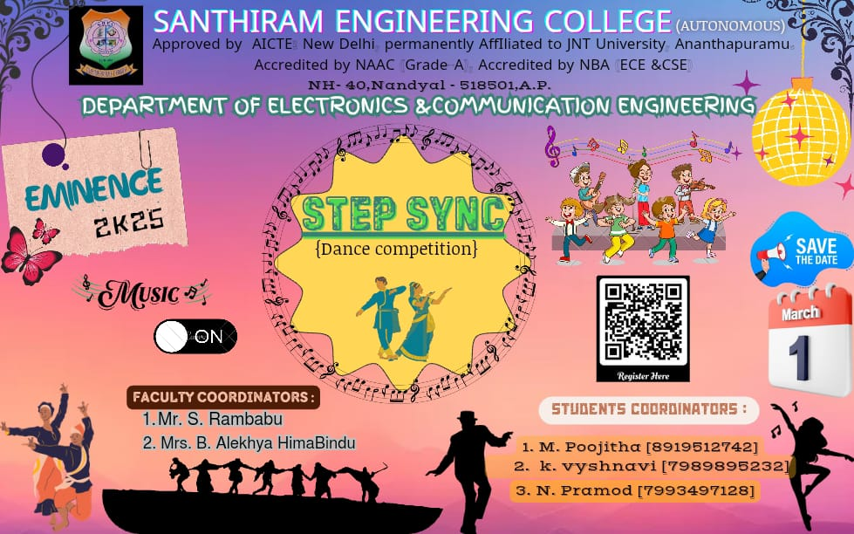

1. Step Sync (Dance Competition) -[bit.ly/4jFzwAX](http://bit.ly/4jFzwAX)

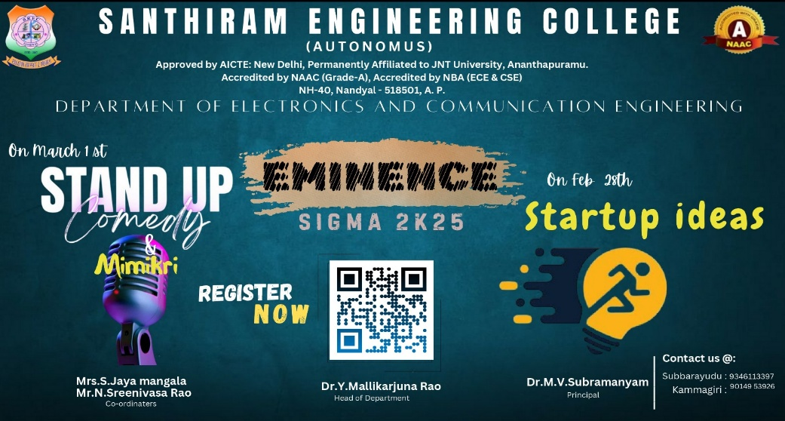

1. Standup Comedy /Mimicry-  <https://shorturl.at/1jvD8>

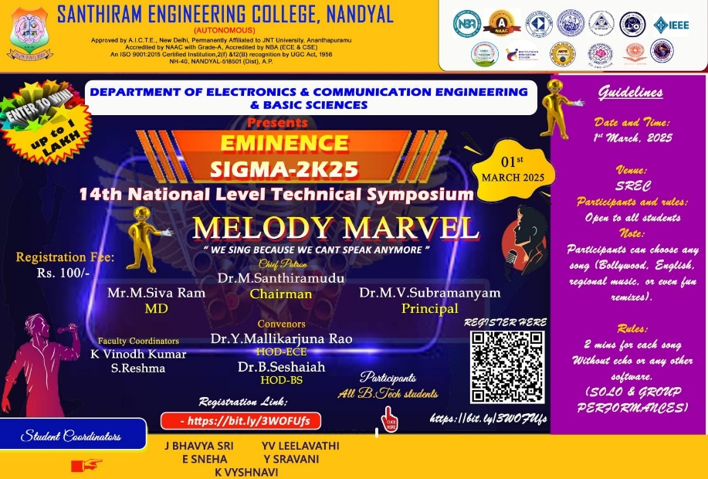

1. Melody Marvel - <https://bit.ly/3WOFUfs>

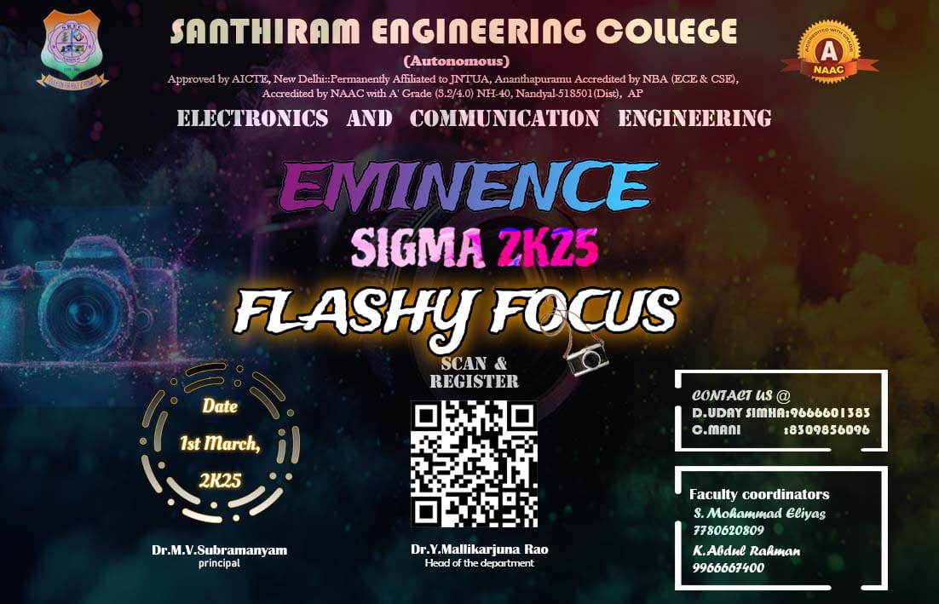

1. Flashy focus    - <https://goto.now/TlHfA>

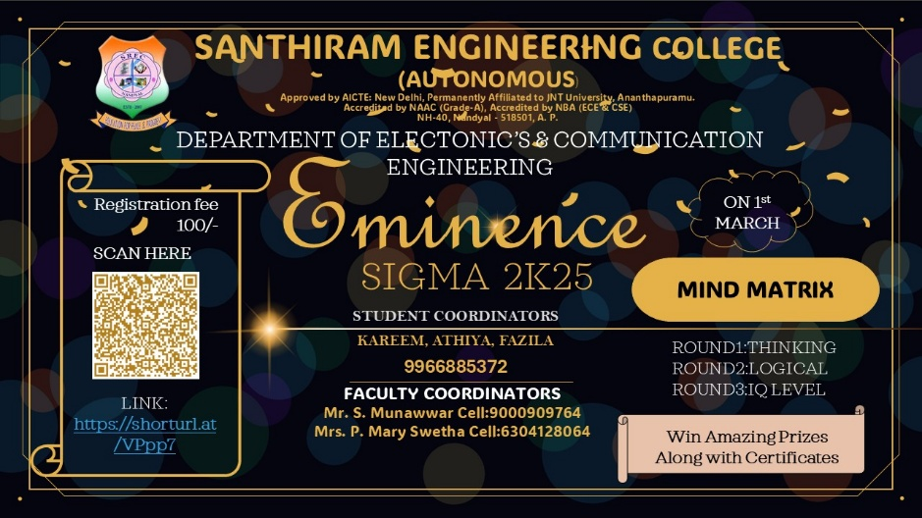

1. Mind Matrix-<https://shorturl.at/VPpp7>

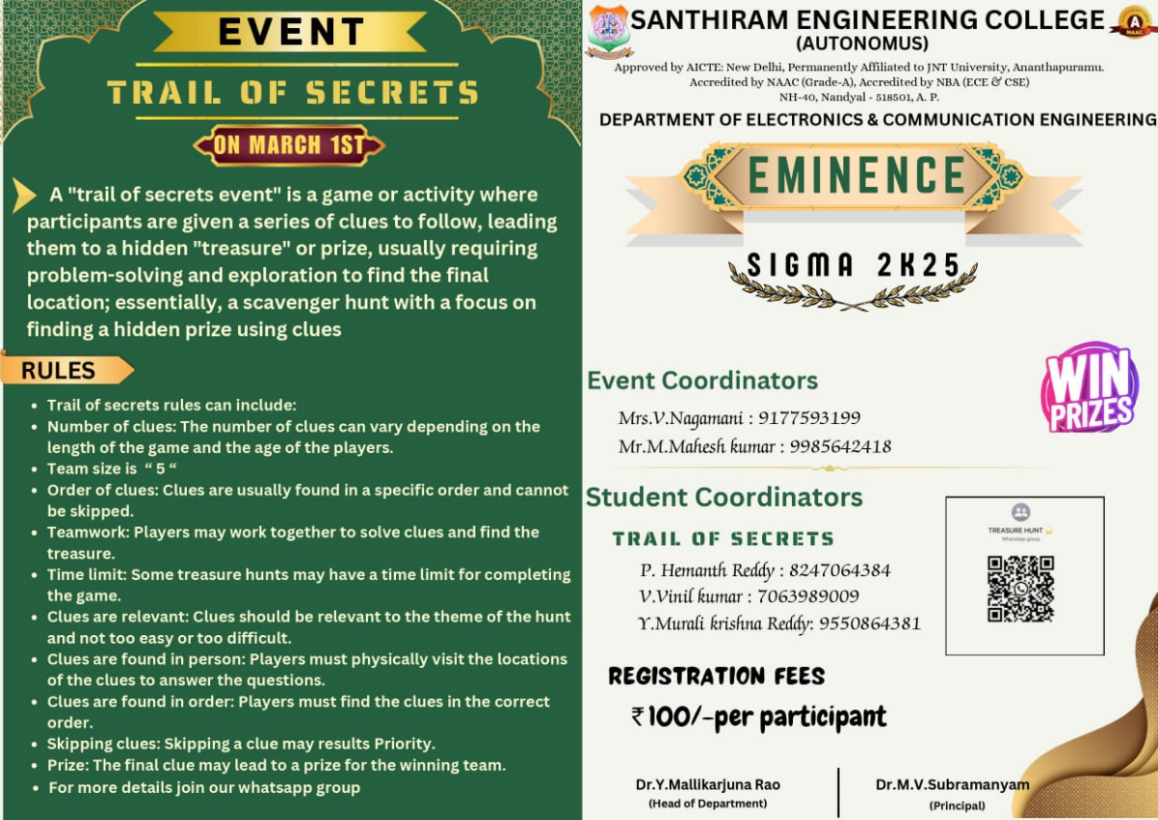

1. Trails of Secrets- <https://forms.gle/yYtpwgr7SFubCceX8>

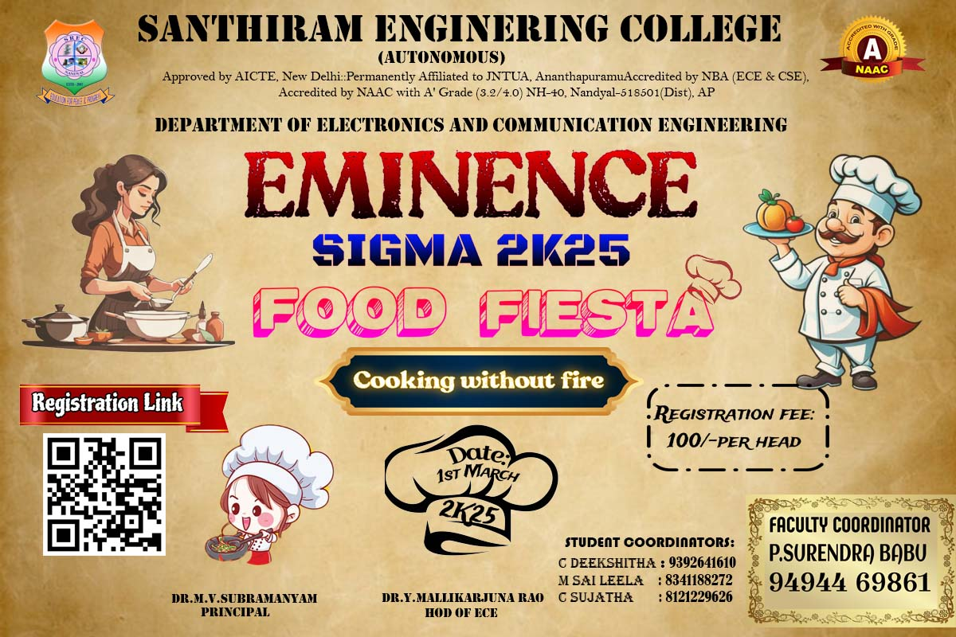

1. Master Chef Challenge  <https://tinyurl.com/4wpus52t>

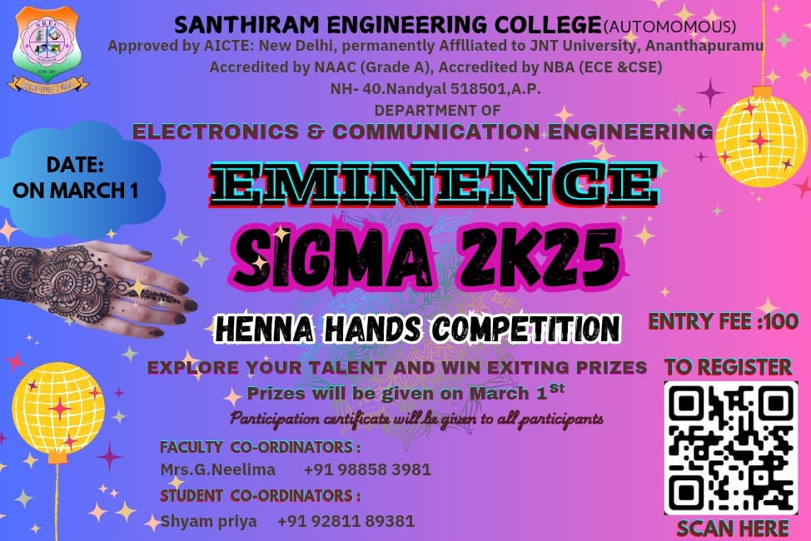

1. Henna hands Challenge - <https://bit.ly/3CGCEfd>

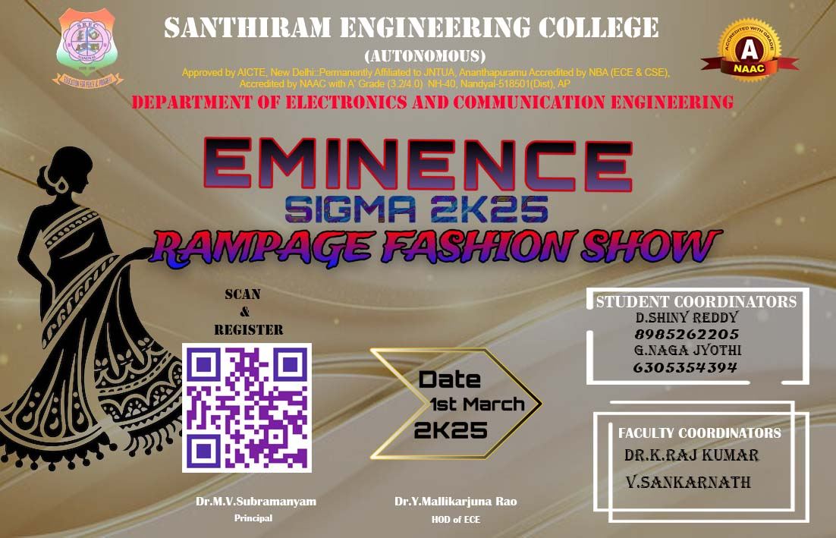

1. Rampage Fashion Show <https://tinyurl.com/yc2eux68>